## **Updating Notepad++ to Handle Markdown**

Notepad++ is the most common plain text editor for Windows computers. These instructions for adding Markdown support to the standard Notepad++ installation come from this site:

<https://adamtheautomator.com/convert-markdown-to-html/>

**Markdown in Notepad++**

[*Notepad++*](https://notepad-plus-plus.org/downloads/) is a popular, free editor with several plugins available that you can install to extend its capabilities. One of these plugins is the *MarkdownViewer++,* which adds the feature to render and export Markdown contents to HTML.

You can install the *MarkdownViewer++* plugin by going to **Plugins —> Plugins Admin**. Once inside the **Plugins Admin** window, select the **MarkdownViewer++** and click on **Install**. When prompted, click **Yes**. Notepad++ will restart automatically.

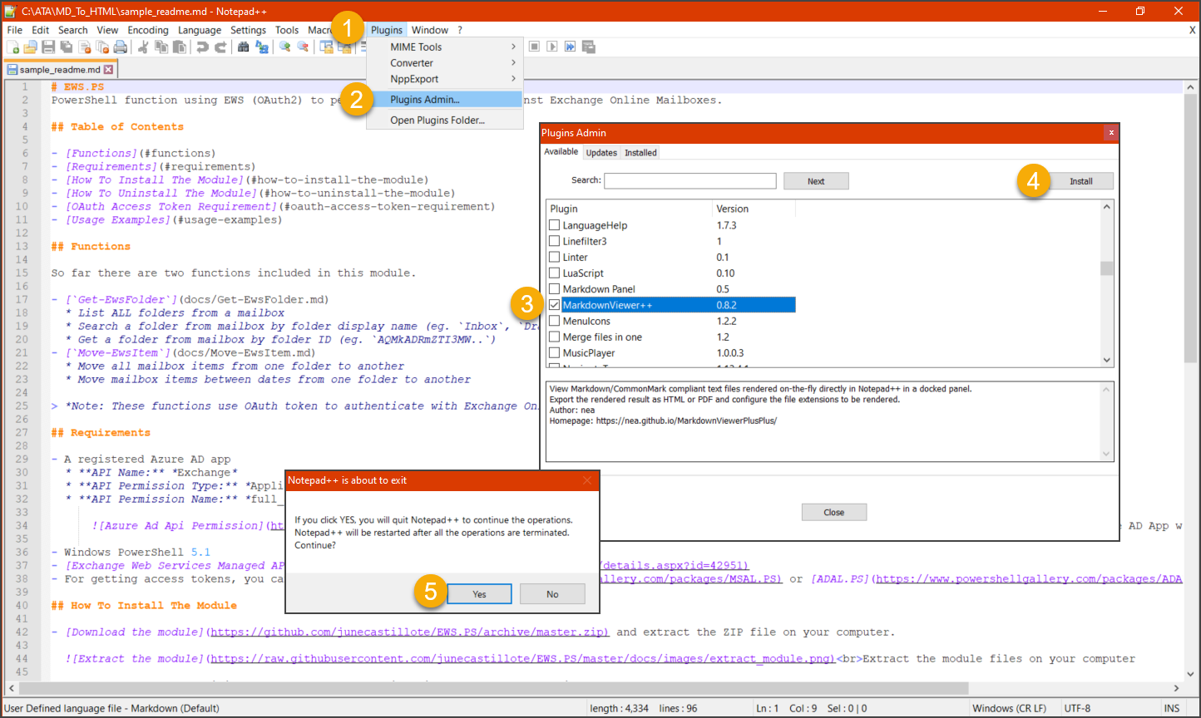

*Installing the MarkdownViewer++ plugin*

After the plugin is installed, open the Markdown file and click on the **MarkdownViewer++** button. The pane where the HTML rendering of the Markdown file should show up. To export the content, click on **Export as —> HTML**. Then, save the file in your chosen location.

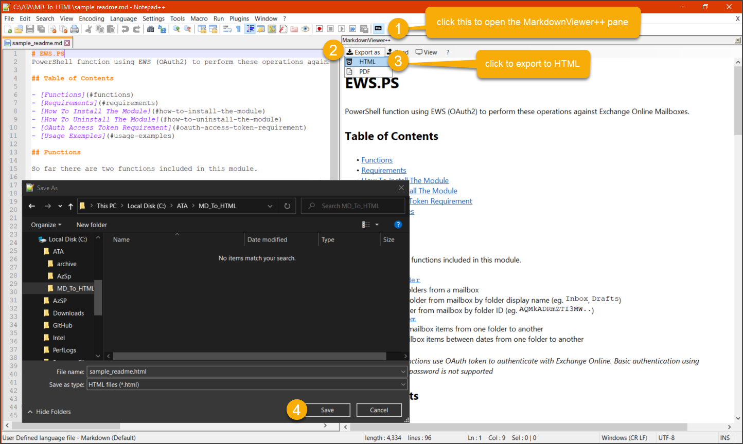

*Convert Markdown to HTML using Notepad++*

Below you can see that the HTML output is plain and has no style formatting.

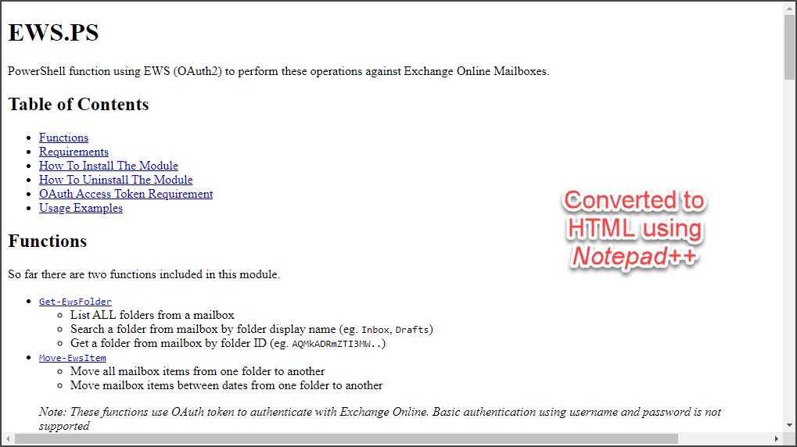

*HTML output format using Notepad++*

## **Using Atom to Handle Markdown**

Atom is a cross-platform plain text editor. These instructions for using Markdown in come from this site: <https://adamtheautomator.com/convert-markdown-to-html/>

### Atom

Another great editor that supports many languages is [*Atom*](https://atom.io/). Atom also comes with packages, that when installed, extend its features further. One of these packages is the markdown-preview, which gives Atom the ability to save markdown content to HTML. Best of all, markdown-preview is already installed by default!

The first step to convert Markdown to HTML is to open your Markdown document in Atom. Then toggle the Markdown preview by pressing the CTRL+SHIFT+M keyboard shortcut. Another way to toggle the Markdown preview is from **Packages —> Markdown Preview —> Toggle Preview**.

Once the preview pane shows up, right-click on the preview and click **Save as HTML**, and save the file in your preferred folder. Refer to the demonstration below.

*Convert Markdown to HTML using Atom*

Below, you can see what the HTML formatted file looks like when exported using Atom. You might recognize that the appearance is similar to how GitHub displays Markdown contents.

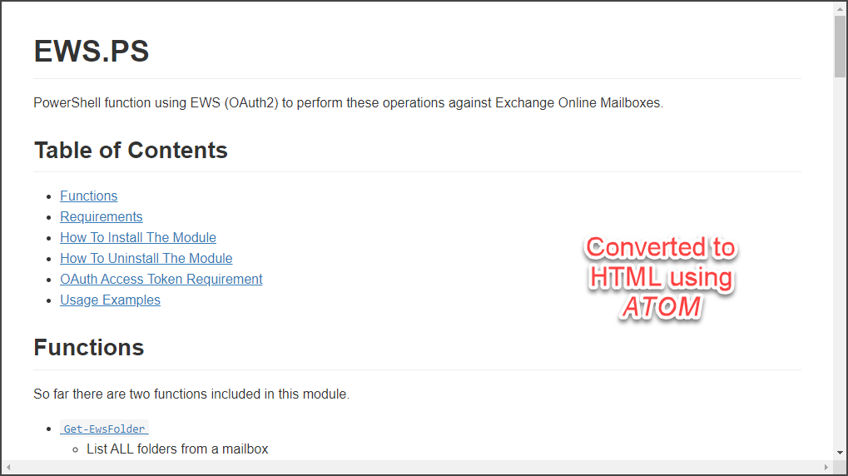*HTML output format using Atom*